Brian Engel

Module 4 Milestone

Create object in database

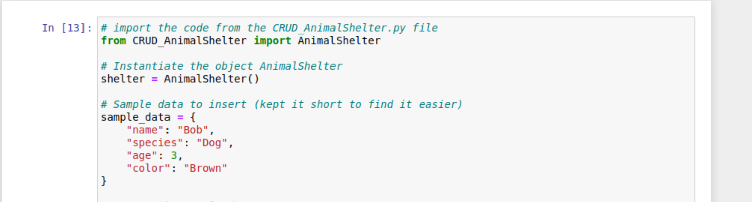

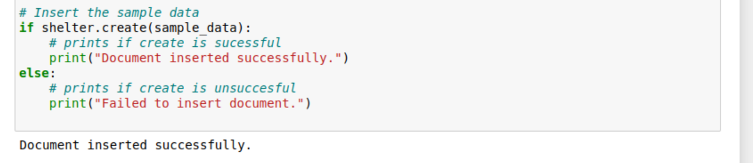

Read name in database

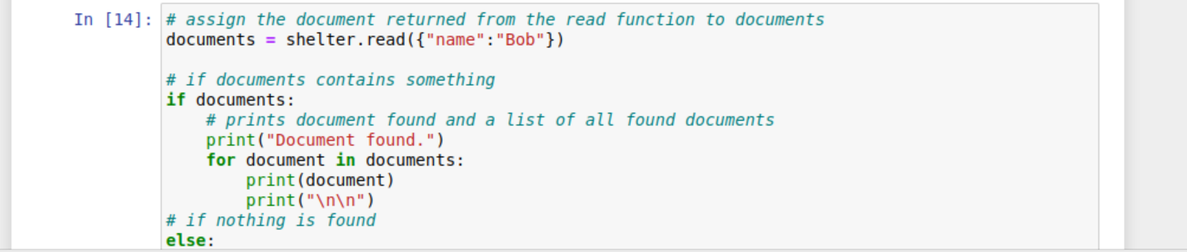

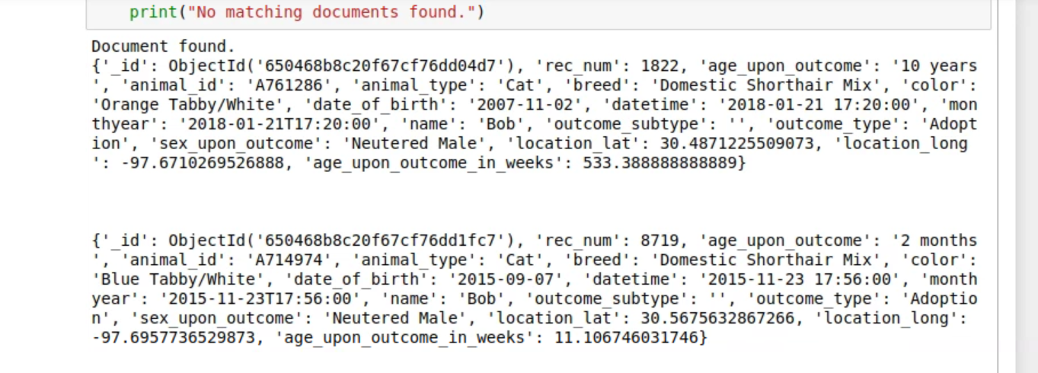

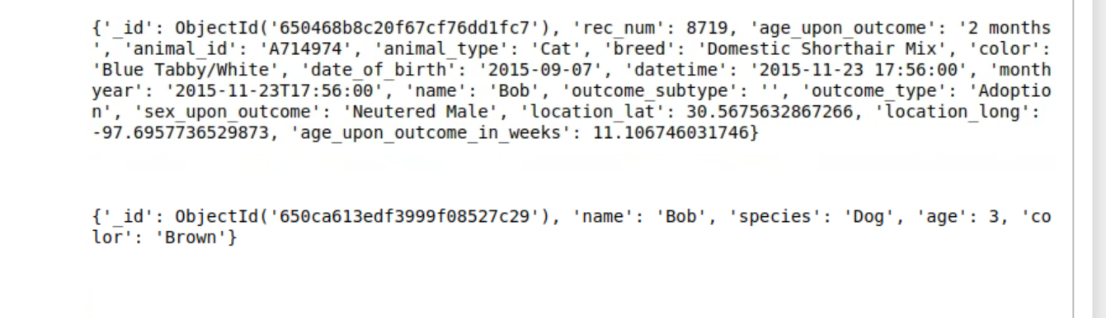

Read name not in database

